FOOTSTEP POWER GENERATION USING ARDIUNO

VIGNESH.S
CB.EN.U4EEE23044
Department of Electrical and Electronics Engineering
Amrita Vishwa Vidyapeetham
Coimbatore,India
cb.en.u4eee23044@cb.students.amrita.edu
THILAK.V.N CB.EN.U4EEE23041
Department of Electrical and Electronics Engineering
Amrita Vishwa Vidyapeetham
Coimbatore,India
cb.en.u4eee23041@cb.students.amrita.edu
J V RAGHAVA ANIRUDH
CB.EN.U4EEE23043 Department of Electrical and Electronics Engineering
Amrita Vishwa Vidyapeetham
Coimbatore,India cb.en.u4eee23043@cb.students.amrita.edu
UDAY KRISHNA.R
CB.EN.U4EEE23042 Department of Electrical and Electronics Engineering
Amrita Vishwa Vidyapeetham
Coimbatore,India
cb.en.u4eee23042@cb.students.amrita.edu

Abstract—The growing demand for sustainable energy solutions has driven the need for innovative power generation methods. This project, "Footstep Power Generation Using Arduino," presents an eco-friendly approach to harvesting energy from human motion. The system utilizes piezoelectric sensors embedded in a flooring mechanism to convert mechanical energy from footsteps into electrical energy. This generated voltage is measured, processed, and displayed using an Arduino-based system with an LCD interface for real-time monitoring .
Keywords— Piezoelectric Energy Harvesting, Sustainable Power Generation, Smart Footstep Energy System.

OBJECTIVE:

The primary objective of this project is to develop an efficient footstep power generation system that converts mechanical energy from human footsteps into usable electrical energy. By utilizing piezoelectric sensors or pressure plates, the system captures kinetic energy and converts it into voltage, which is then processed and displayed in real-time using an Arduino-based monitoring system with an I2C LCD module. Additionally, the project aims to implement an optimized step detection algorithm to ensure accurate footstep counting while minimizing false triggers. The generated energy will be stored in a rechargeable battery or capacitor for practical applications such as LED lighting, IoT devices, or low-power electronic systems. This innovative approach not only enhances energy efficiency but also contributes to the development of sustainable and smart infrastructure, making it suitable for public spaces, transportation hubs, and high-footfall areas to support green energy solutions

CONSTRUCTION:
The footstep power generation system consists of several key components integrated to convert mechanical energy from footsteps into electrical energy. piezoelectric sensors arranged in a series configuration. These sensors are embedded within a platform, such as a footpath or tile, to capture the mechanical stress exerted by footsteps.
The sensors are connected to a rectifier circuit to convert the generated AC voltage to DC voltage. The generated voltage is regulated using a voltage regulator to ensure stable output.
The electrical energy is stored in rechargeable batteries or directly used to power small devices. An Arduino Uno microcontroller is responsible for processing the input voltage data. It reads the analog signals from the sensors using its ADC (Analog to Digital Converter) and calculates the voltage generated. A 16x2 LCD display connected to the Arduino via an I2C interface is used to display the real-time voltage generated and the step count.
Additionally, an LED indicator is triggered for visual feedback whenever a step is detected. Supporting components like transistors, resistors, and capacitors are placed on a breadboard for ease of assembly and testing.
A rechargeable battery pack stores the generated energy for later use. The system is a sustainable and low-maintenance setup suitable for public places like railway stations and airports.

SENSORS USED:

Piezoelectric Sensors :

-These sensors are responsible for converting the mechanical energy from footsteps into electrical energy using the piezoelectric effect.
-When a person steps on the piezoelectric discs, they generate an electrical voltage proportional to the applied pressure.
-The generated voltage is then stored or used to power devices, and it is monitored using the Arduino.

Voltage Sensor :

-The Arduino reads the voltage generated by the piezoelectric sensors through the analog pin (A0).
This sensor helps in monitoring and displaying the voltage output on the 16x2 LCD using the I2C interface.

WORKING PROCESS:

Energy Generation:

-Piezoelectric sensors generate voltage when subjected to mechanical pressure (footsteps).

Signal Processing:

-The generated voltage is fed into a rectifier circuit to convert AC to DC.

Storage:

-The DC voltage is stored in rechargeable batteries.

Monitoring and Display:

-The Arduino reads the voltage using an analog input pin and calculates the step count.

-voltage and step count are displayed on the LCD.

LED Indication:

-An LED indicator lights up for every detected footstep. Authors and Affiliations.

circuit diagram

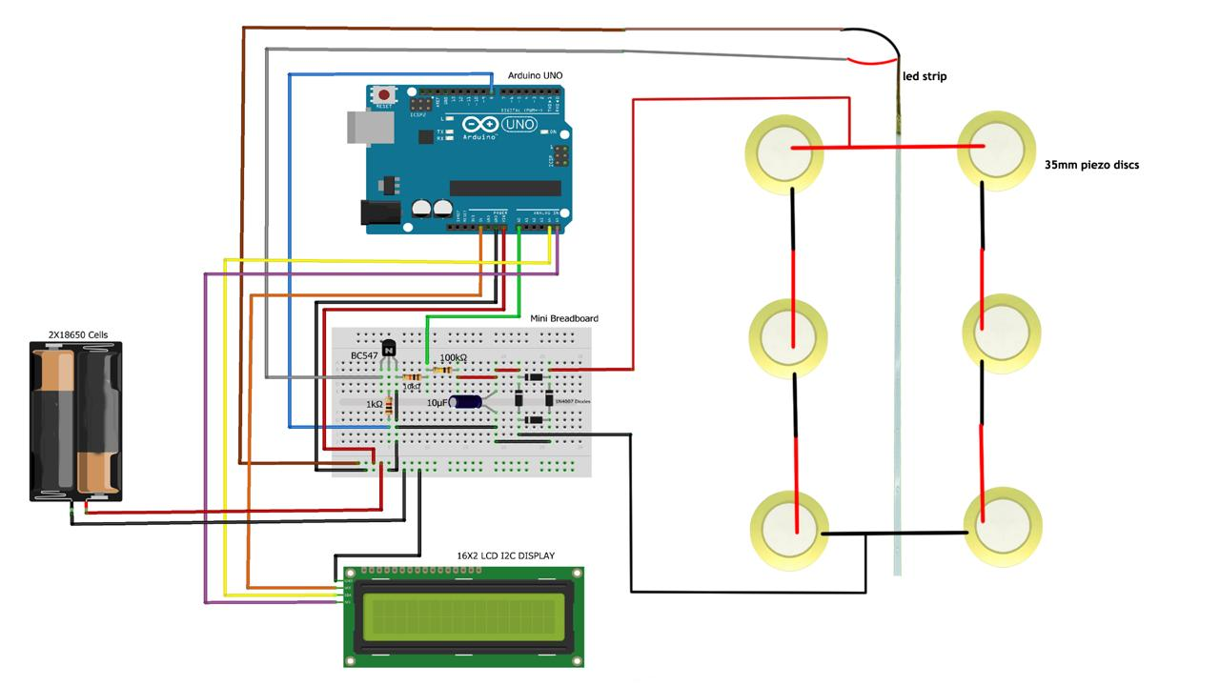

BLOCK DIAGRAM:

The block diagram represents a footstep power generation system that uses piezoelectric sensors, an Arduino controller, and an LCD display. When a user steps on the sensors, the mechanical energy from the footstep is converted into electrical energy through the piezoelectric effect. The Arduino then measures the generated voltage, processes the data, and tracks the number of footsteps. This information is displayed on the LCD screen using I2C communication. Additionally, an LED lights up with each detected step, providing visual feedback. This system effectively harnesses energy from human movement, making it an eco-friendly solution for generating electricity in high-traffic areas such as train stations, malls, and airports.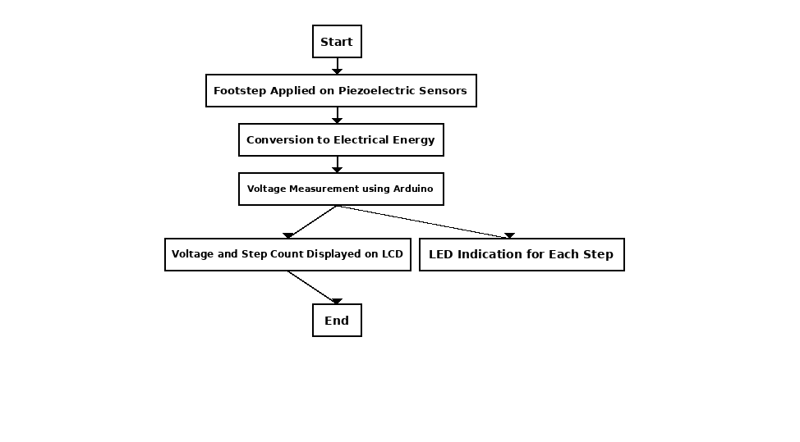

CONCLUSION

The footstep power generation system effectively converts mechanical energy from human footsteps into usable electrical energy using piezoelectric sensors. By utilizing an Arduino Uno for data processing and monitoring, the system provides real-time information on energy generation and step count through an LCD display. This renewable energy solution is cost-effective, environmentally friendly, and easy to implement in crowded public areas. It demonstrates the potential of harvesting energy from daily human activities, contributing to sustainable energy management and reducing reliance on conventional power sources.

IEEE conference templates

